**React HandsOn 9**

Create a React Application named “cricketapp” with the following components:

1. ListofPlayers

* Declare an array with 11 players and store details of their names and scores using the map feature of ES6
* Filter the players with scores below 70 using arrow functions of ES6.

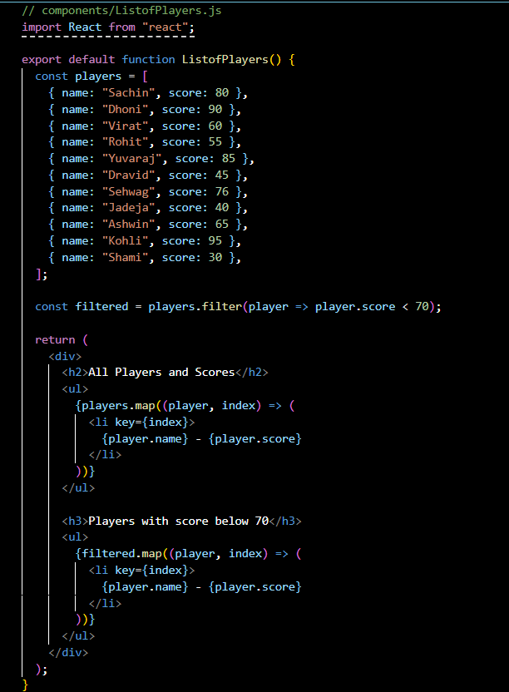

1. IndianPlayers
   1. Display the Odd Team Player and Even Team players using the Destructuring features of ES6
   2. Declare two arrays T20players and RanjiTrophy players and merge the two arrays and display them using the Merge feature of ES6

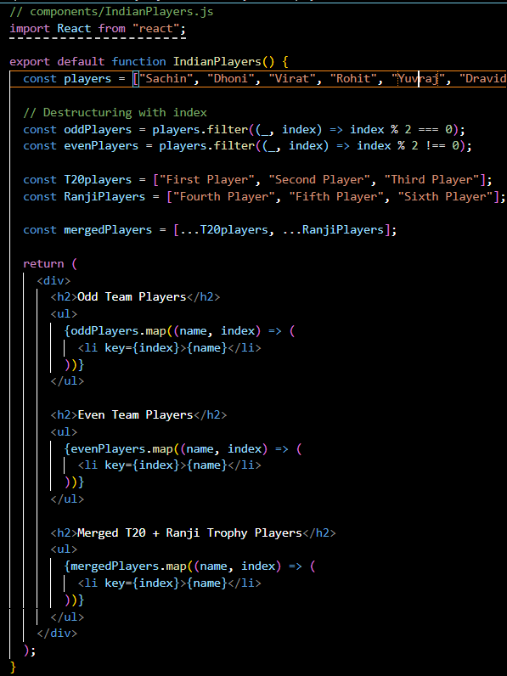

Display these two components in the same home page using a simple if else in the flag variable.

**App.js**

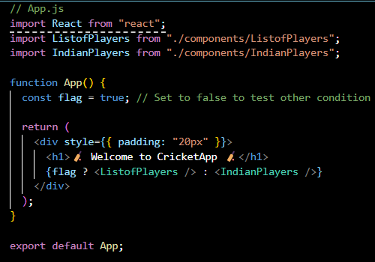

**Output:**

When Flag=true



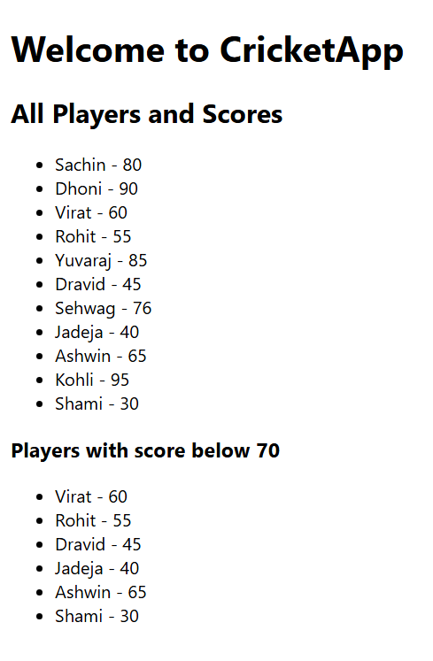

When Flag=false



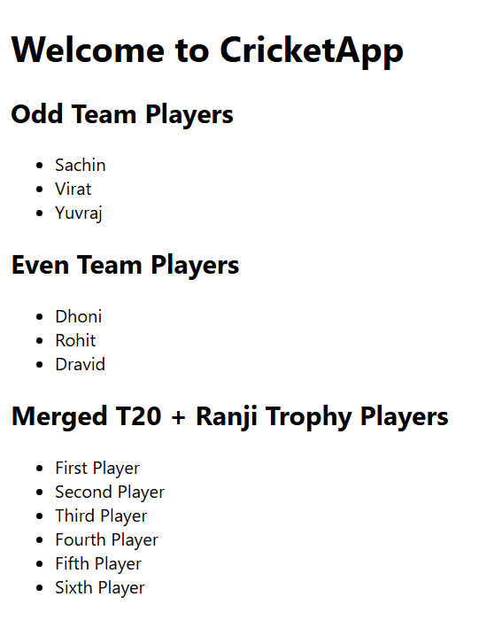

**React HandsOn 10**

Create an element to display the heading of the page.

Attribute to display the image of the office space

Create an object of office to display the details like Name, Rent and Address.

Create a list of Object and loop through the office space item to display more data.

To apply Css, Display the color of the Rent in Red if it’s below 60000 and in Green if it’s above 60000.

**OfficeApp.js:**

import React from "react";

const offices = [

  {

    name: "Office A",

    rent: 55000,

    address: "Sector 5, Salt Lake",

    image: "https://tse4.mm.bing.net/th/id/OIP.y-JCbcWu_PkOmnJzr4e1KQHaE7?pid=Api&P=0&h=180",

  },

  {

    name: "Office B",

    rent: 72000,

    address: "Kolkata, Rajarhat",

    image: "https://tse2.mm.bing.net/th/id/OIP.FpOe13DnZ678OQ2GX8MPIQHaE8?pid=Api&P=0&h=180",

  },

  {

    name: "Office C",

    rent: 48000,

    address: "New Town",

    image: "https://tse4.mm.bing.net/th/id/OIP.HfKRI-KYFgwmWdq-FxFYKgHaE7?pid=Api&P=0&h=180",

  },

];

export default function OfficeApp() {

  return (

    <div style={{ padding: "20px", fontFamily: "Arial" }}>

      <h1>Available Office Spaces</h1>

      <h2>Featured Office</h2>

      <div style={{ border: "1px solid #ccc", padding: "10px", marginBottom: "20px" }}>

        <img

          src="https://tse3.mm.bing.net/th/id/OIP.xiLvvQ02gdFhWvwqA98q2gHaE8?pid=Api&P=0&h=180"

          alt="Office"

          style={{ width: "50%", borderRadius: "5px" }}

        />

        <p><strong>Name:</strong> Prime Offices</p>

        <p>

          <strong>Rent:</strong>{" "}

          <span style={{ color: 65000 < 60000 ? "red" : "green" }}>₹65000</span>

        </p>

        <p><strong>Address:</strong> BBD Bag, Kolkata</p>

      </div>

      <h2>Other Available Offices</h2>

      {offices.map((office, index) => (

        <div

          key={index}

          style={{

            border: "1px solid #aaa",

            padding: "10px",

            marginBottom: "15px",

            borderRadius: "5px",

          }}

        >

          <img

            src={office.image}

            alt={office.name}

            style={{ width: "100%", maxWidth: "300px", borderRadius: "5px" }}

          />

          <p><strong>Name:</strong> {office.name}</p>

          <p>

            <strong>Rent:</strong>{" "}

            <span style={{ color: office.rent < 60000 ? "red" : "green" }}>

              ₹{office.rent}

            </span>

          </p>

          <p><strong>Address:</strong> {office.address}</p>

        </div>

      ))}

    </div>

  );

}

**App.js:**

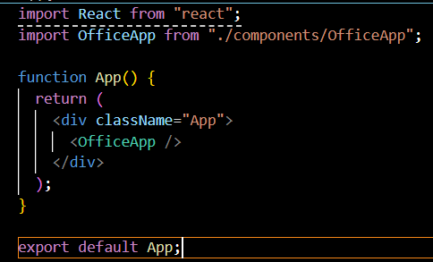

import React from "react";

import OfficeApp from "./components/OfficeApp";

function App() {

  return (

    <div className="App">

      <OfficeApp />

    </div>

  );

}

export default App;

Output:

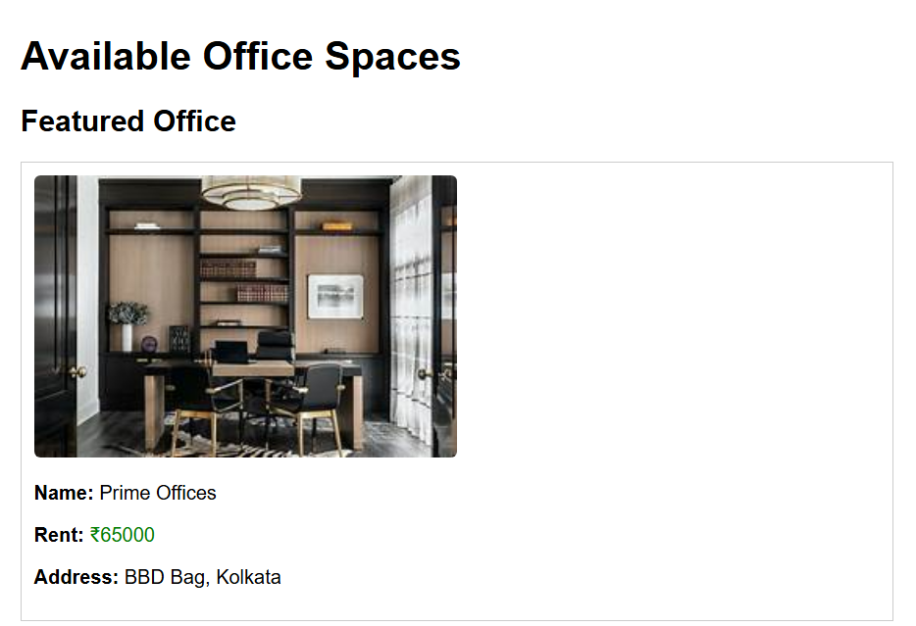

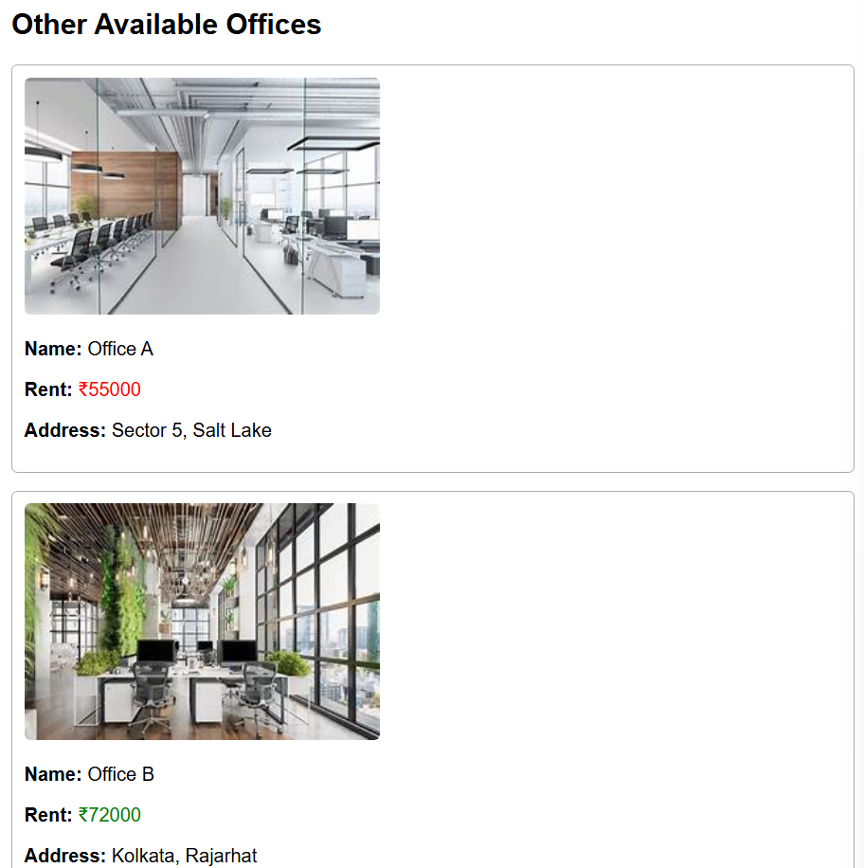

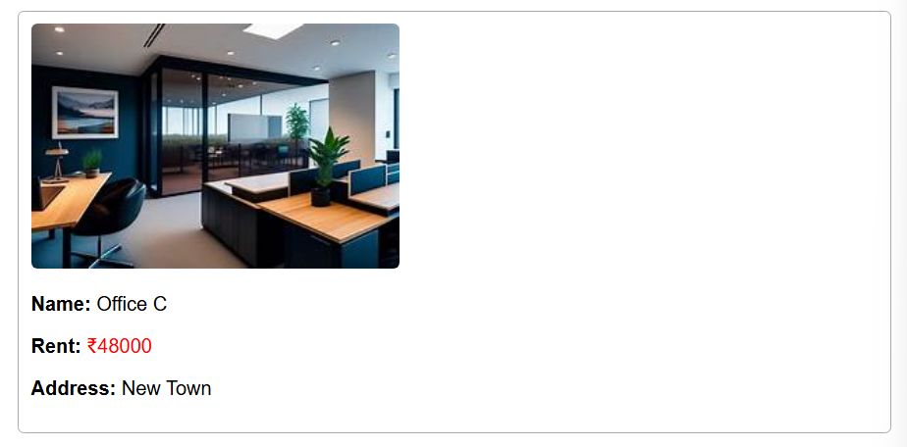

**React HandsOn 11**

Create a React Application “eventexamplesapp” to handle various events of the form elements in HTML.

1. Create “Increment” button to increase the value of the counter and “Decrement” button to decrease the value of the counter. The “Increase” button should invoke multiple methods.
   1. To increment the value
   2. Say Hello followed by a static message.

**Counter.js**

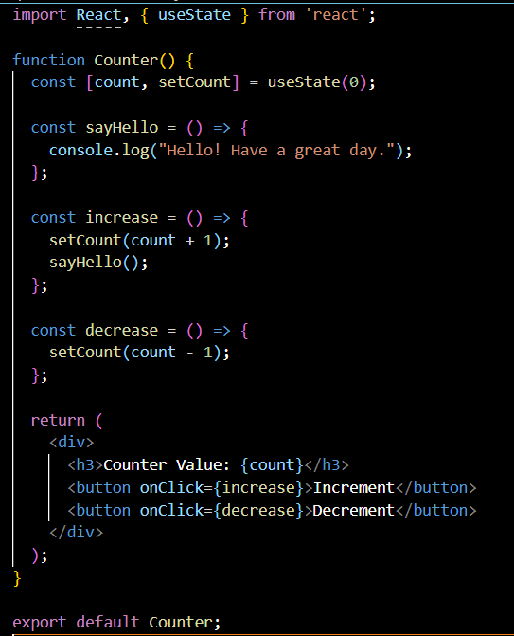

1. Create a button “Say Welcome” which invokes the function which takes “welcome” as an argument.

**SayWelcome.js**

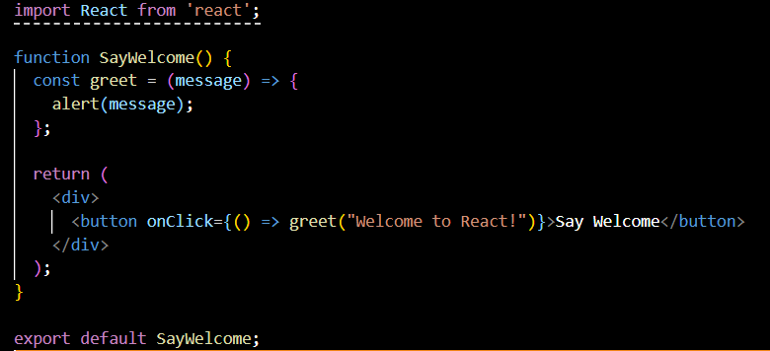

1. Create a button which invokes synthetic event “OnPress” which display “I was clicked”

**ClickMessage.js**

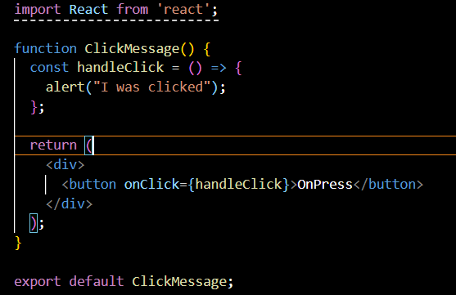

Create a “CurrencyConvertor” component which will convert the Indian Rupees to Euro when the Convert button is clicked.

Handle the Click event of the button to invoke the handleSubmit event and handle the conversion of the euro to rupees.

**CurrencyConverter.js**

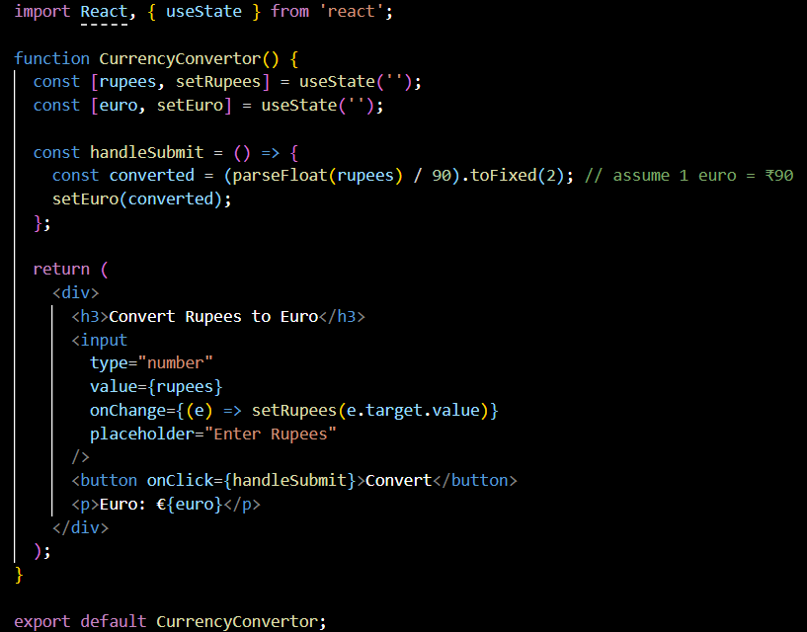

**App.js**

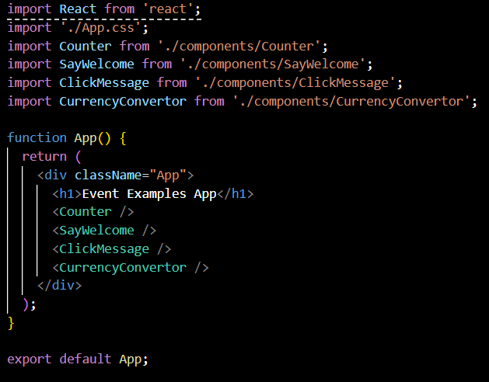

OUTPUT:

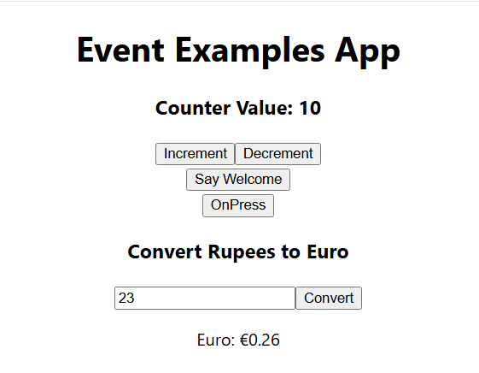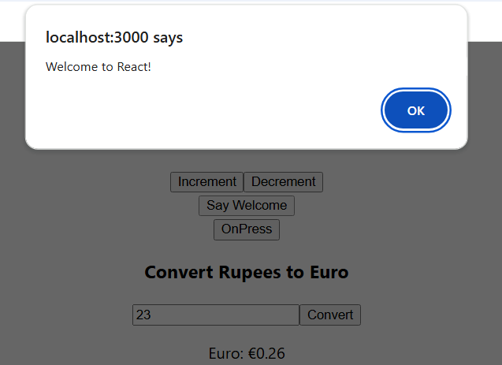

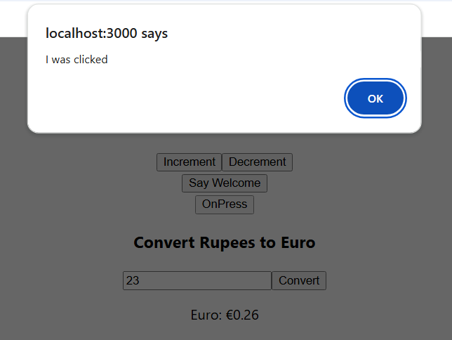

**React HandsOn 12**

Create a React Application named “ticketbookingapp” where the guest user can browse the page where the flight details are displayed whereas the logged in user only can book tickets.

The Login and Logout buttons should accordingly display different pages. Once the user is logged in the User page should be displayed. When the user clicks on Logout, the Guest page should be displayed.

**GuestPage.js**

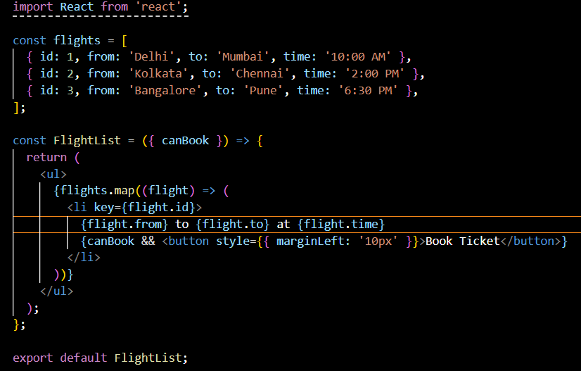

**UserPage.js**

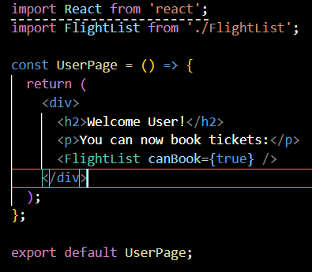

**FlightList.js**

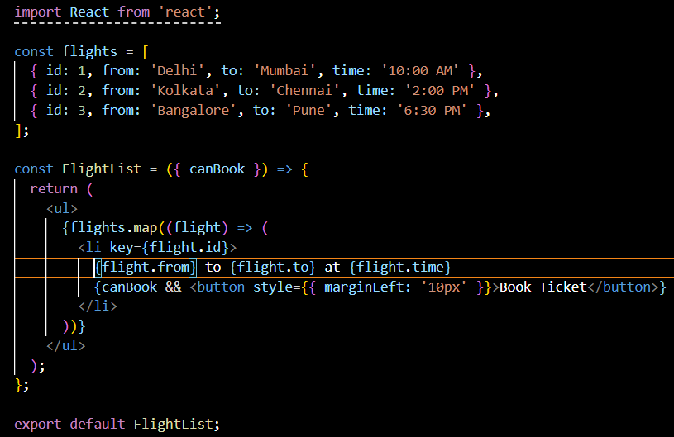

**LoginButton.js**

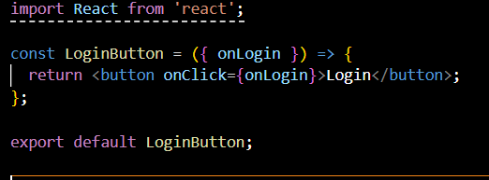

**LogoutButton.js**

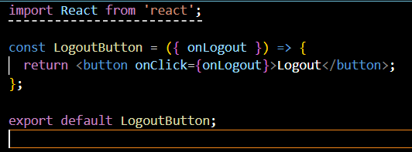

**App.js**

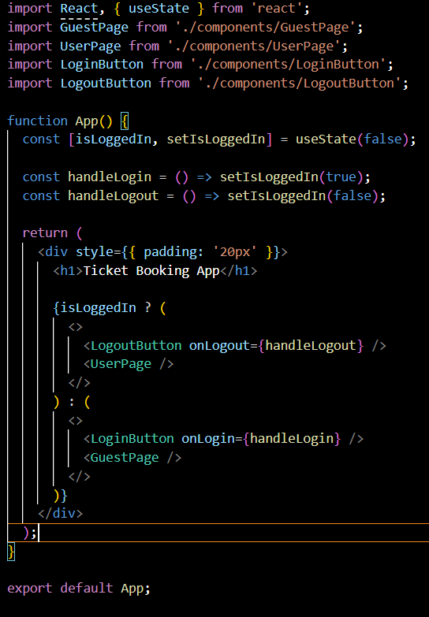

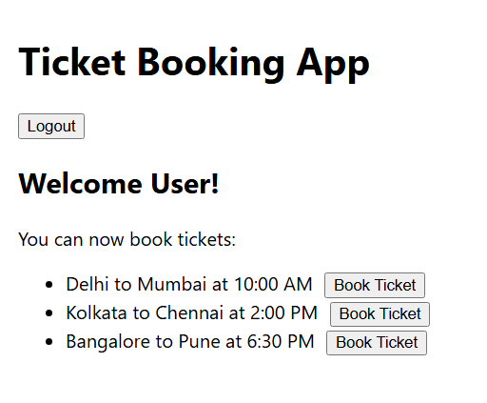**OUTPUT:**

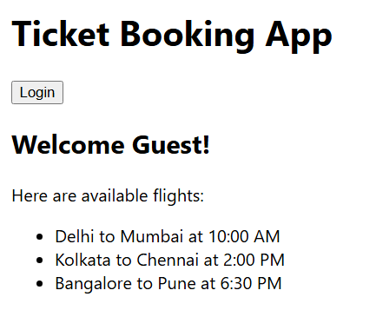

**React HandsOn 13**

Create a React App named “bloggerapp” in with 3 components.

1. Book Details
2. Blog Details
3. Course Details

Implement this with as many ways possible of Conditional Rendering.

**BookDetails.js**

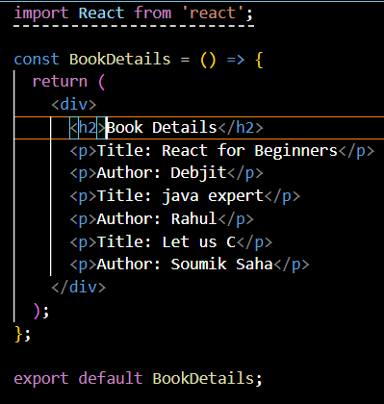

**BlogDetails.js**

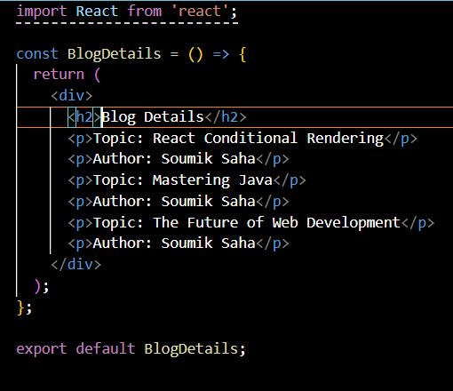

**CourseDetails.js**

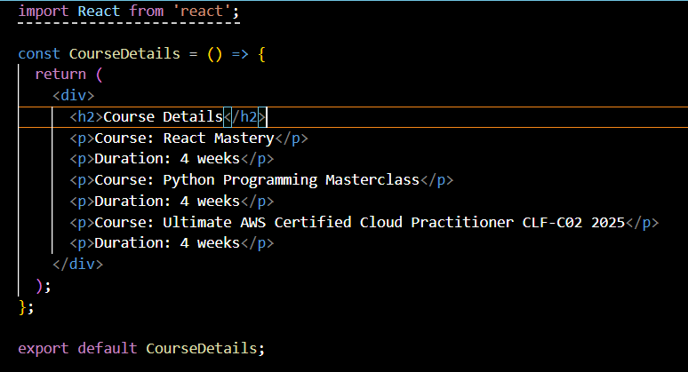

**App.js**

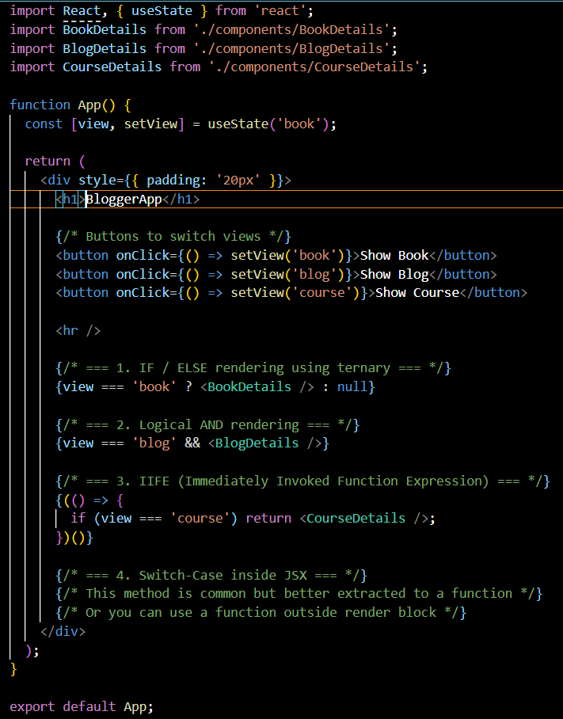

**Output:**

 